Supplementary Online Material for:
Dune, outcrop, and pan sediments from the southern Kalahari basin: A case study from the Kgalagadi district, Botswana
by: Inèz Faul, Taylor Grandfield, Stefan Dreibrodt, Sarah Mothulatshipi, Phillip Segadika, Christopher Green, Marine Frouin, Michaela Ecker
Content:
Table 1
Figures 1-10
Additional supplementary material, such as raw data files for XRF, XRD, and Mastersizer analyses can be provided on request per email to the corresponding author (ifaul@ufg.uni-kiel.de). An additional Excel file with a summary of all data is available online (SOM 2).
Table 1: A summary of the geoarchaeological field observations made in 2022 for all samples, including the depth of the bulk sediment sample and the profile that it originated from, as well as the GRADISTAT sorting and textural groups.
Name | Field Description | Sample depth below surface | Gradistat sorting | Gradistat textural group | Max depth of profile (cm)
ITI-T1 | Single-grained loose sandy sediment. Munsell colour 5YR5/6. High frequency of angular gravels, with a size range of ≤ 30cm. The profile is gravel supported. | ± 10-40cm | Moderately Sorted | Sand | 65
ITI-T2 | Single-grained loose sandy sediment. Munsell colour 6/7.5 YR from 0-20cm and 7.5YR from 20-38cm. The profile is gravel supported. | ± 10-20cm | Moderately Sorted | Sand | 38
MAL Quarry Bed 1 (surface) | Blocky surface layer. Munsell colour 2.5Y8/1. A highly cemented surface layer. | 32 cm | Poorly Sorted | Muddy Sand | 190-200
MAL Quarry Bed 2 | Blocky calcareous sediment. Munsell colour 2.5Y8/1. A matrix supported cemented layer. | 40 cm | Poorly Sorted | Muddy Sand | 190-200
MAL Quarry Bed 3 | Granular calcareous sediment. Munsell colour 2.5Y8/3. A matrix-supported, highly cemented, hard calcareous sediment. Black stains on the surface. | 63 cm | Poorly Sorted | Muddy Sand | 190-200
MAL Quarry Bed 4 (Upper) | Granular calcareous sediment. Munsell colour 2.5Y8/2. | 100 cm | Poorly Sorted | Muddy Sand | 190-200
MAL Quarry Bed 4 (Middle) | Granular calcareous sediment. Munsell colour 2.5Y8/2. | 120 cm | Poorly Sorted | Muddy Sand | 190-200
MAL Quarry Bed 4 (Lower) | Granular calcareous sediment. Munsell colour 2.5Y8/2. | 135 cm | Poorly Sorted | Muddy Sand | 190-200
MAL Quarry Bed 5 | Blocky calcareous sediment. Munsell colour 5Y8/1. | 200 cm | Very Poorly Sorted | Muddy Sand | 190-200
MLD 1.1 | Fine-grained loose sandy sediment. Munsell colour 10YR8/2. Samples were taken every 50cm from this profile. No visible stratigraphy. The profile is matrix-supported and bioturbation is visible (termite burrows, ant holes, and plant roots) | 50 cm | Poorly Sorted | Sand | 190
MLD 1.2 | Fine-grained loose sandy sediment. Munsell colour 10YR8/2. Samples were taken every 50cm from this profile. No visible stratigraphy. The profile is matrix-supported and bioturbation is visible (termite burrows, ant holes, and plant roots) | 100 cm | Poorly Sorted | Sand | 190
MLD 1.3 | Fine-grained loose sandy sediment. Munsell colour 10YR8/2. Samples were taken every 50cm from this profile. No visible stratigraphy. The profile is matrix-supported and bioturbation is visible (termite burrows, ant holes, and plant roots) | 150 cm | Poorly Sorted | Muddy sand | 190
MLD 1.4 | Fine-grained loose sandy sediment. Munsell colour 10YR8/2. Samples were taken every 50cm from this profile. No visible stratigraphy. The profile is matrix-supported and bioturbation is visible (termite burrows, ant holes, and plant roots) | 180 cm | Poorly Sorted | Sand | 190
MLD 2.1 | Sandy layer (no visible stratigraphy). Profile is matrix supported. Munsell colour 10YR6/6. Fine-grained sediment with roots visible in the profile. | 70 cm | Moderately Well Sorted | Sand | 214
MLD 2.2 | Sandy layer (no visible stratigraphy). Profile is matrix supported. Munsell colour 10YR6/6. Fine-grained sediment with roots visible in the profile. | 140 cm | Moderately Well Sorted | Sand | 214
MLD 2.3 | Sandy layer (no visible stratigraphy). Profile is matrix supported. Munsell colour 10YR6/6. Fine-grained sediment with roots visible in the profile. | 210 cm | Moderately Sorted | Sand | 214
LET Quarry Profile 1 Bed 1 | A blocky duricrust that is cemented. Munsell colour 10YR8/1. Calcrete clasts that are less than 10cm in size were visible in this profile. Some insect burrows are visible. | 13 cm | Poorly Sorted | Muddy sand | 180
LET Quarry Profile 1 Bed 2 | A blocky duricrust that is cemented. Munsell colour 2.5Y8/1. Some red and green sediment infills are visible. | 27 cm | Very Poorly Sorted | Muddy Sand | 180
LET Quarry Profile 1 Bed 3 | A blocky duricrust that is cemented. Munsell colour 5Y8/1. Bioturbation is visible. | 104 cm | Very Poorly Sorted | Muddy Sand | 180
LET Quarry Profile 2 | Fine (powdery) slightly cemented calcareous profile. Munsell colour 10YR7/2. One sample was taken at 88cm. A bioturbated and cracked upper section is present | 88 cm | Very Poorly Sorted | Muddy Sand | 180
MAR QCE 1 Surface | Blocky/massive cemented duricrust. Munsell colour 2.5Y8/1. A highly cemented layer. | 3 cm | Very Poorly Sorted | Muddy Sand | 150
MAR QCE 1 Bed 1 | Granular, slightly cemented duricrust layer. Munsell colour 2.5Y8/2. Calcite cemented sand layer with chalky residue. | 35 cm | Poorly Sorted | Mud | 150
MAR QCE 1 Bed 2 | Granular, slightly cemented duricrust layer. Munsell colour 5Y8/2. Calcite cemented sand layer with chalky residue. | 100 cm | Very Poorly Sorted | Muddy Sand | 150
MAR-T1 Bed 1 Upper | Fine-grained loose sandy sediment with calcite nodules. Munsell colour 2.5Y6/4 calcite nodules and gastropods present. | 31-38 cm | Poorly Sorted | Muddy Sand | 150
MAR-T1 Bed 1 Lower | Fine-grained loose sandy sediment with calcite nodules. Munsell colour 2.5Y6/4 calcite nodules and gastropods present. | 85-92 cm | Poorly Sorted | Muddy Sand | 150
MAR-T1 Bed 2 (Calcrete) | A more prominently calcareous layer that is clast-supported, but still fine-grained. Munsell colour 2.5Y6/3. Lowermost layer was moist at the time of sampling. No gastropod remains present. | 127-135 cm | Poorly Sorted | Muddy Sand | 150
MAR-T2 | Sand and gravel. Munsell 7.5 YR 5/6. A loose sandy layer with no visible stratigraphy. Clasts are ≤ 12 cm. Lithics were excavated from this pit. | 9-22 cm | Moderately Sorted | Sand | 37
MAR-G1 Bed 1 | Powdery calcite layer. Slightly cemented. Munsell colour 5Y8/1. The contact with the lower bed is visible. | 6 cm | Very Poorly Sorted | Muddy Sand | 110
MAR-G1 Bed 2 (Upper) | Calcite cemented sand. Munsell colour 2.5Y7/4. Matrix supported with a granular structure. | 28 cm | Very Poorly Sorted | Muddy Sand | 110
MAR-G1 Bed 2 (Lower) | Calcite cemented sand. Munsell colour 2.5Y7/4. Matrix supported with a granular structure. | 70 cm | Very Poorly Sorted | Muddy Sand | 110
MAR-G1 Bed 3 | Calcite cemented sand with calcareous gravel inclusions. Munsell colour 2.5Y7/4. Matrix supported with a granular structure. | 96 cm | Very Poorly Sorted | Muddy Sand | 110

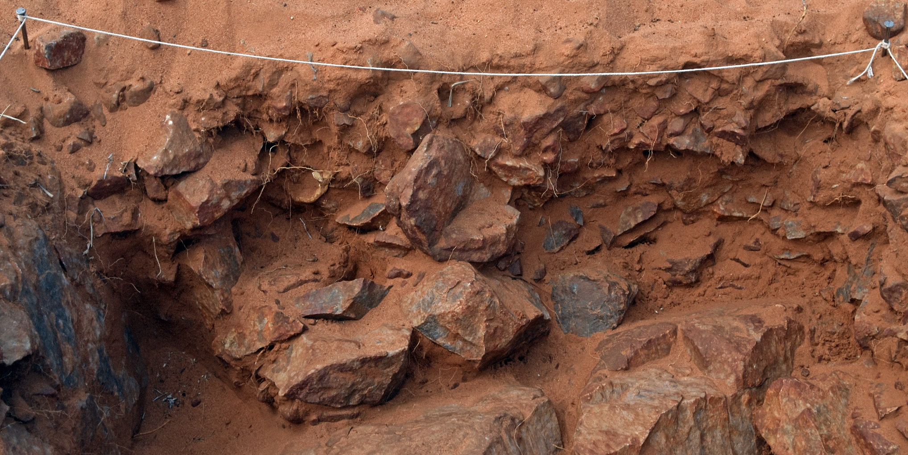
Figure 1: Profile image of archaeological test-pit ITI-T2 located on a raw material outcrop.
Figure 2: XRD graph with peaks for MAR-G1 Bed 1.
Figure 3: XRD graph with peaks for MAR-G1 Bed 2 (Upper).
Figure 4: XRD graph with peaks for MAR-G1 Bed 2 (Lower).
Figure 5: XRD graph with peaks for MAR-G1 Bed 3.
Figure 6: XRD graph with peaks for MAR-QCE 1 Bed 2.
Figure 7: XRD graph with peaks for MAR-T1 Bed 1 (Upper).
Figure 8: XRD graph with peaks for MAR-T1 Bed 1 (Lower).
Figure 9: XRD graph with peaks for MAR-T1 Bed 2 (Calcrete).
Figure 10: XRD graph with peaks for MAR-T2.

