supplementary online material – methods used in illustration of rock paintings for Parkington and Alfers
Compiled by Royden Yates (royden.yates@gmail.com)

Introduction
Illustrations of rock paintings presented in Parkington and Alfers are all derived from digital imagery, acquired either by scanning slide film or directly by digital camera. They are enhancements as opposed to edited (colloquially termed ‘Photoshopped’) or redrawn images, in that the manipulations address pixel values without selection for where the pixels lie within the image.

Enhancing rock paintings entails exaggerating the colours and/or contrasts of an image. There are many ways to do this. In the present case, derivative images were first obtained by performing either a decorrelation stretch or a chromaticity extraction on the image original. These intermediary images then served as a source of useful overlays to be manipulated in image editing software such as the open-source GIMP (The GIMP Development Team 2022). Stages in this process are detailed below.

1. Colour cast correction
Colour casts can affect image contrasts, particularly if severe. One well-known cause of colour casts is due to the deterioration of the emulsion of photographic film and is particularly acute in slide film when stored without climate control. Such deterioration is evident in many of the scanned collections housed in The African Rock Art Digital Archive (ARADA 2022), demonstrating the importance of that project in transferring the images to digital media. Colour casts are not just an issue with film images; even with auto-white balancing in digital camera, images may be tinted by sunlight reflecting off oxidised sand or rock. Irrespective of cause, colour casts ideally should be dealt with before enhancement.

Unlike some commercial software, GIMP does not offer a built-in function for colour cast correction, but it can be achieved using layer modes (more on modes below). One method is to divide the colour cast image by its average colour, then multiplying by the desaturated average colour (see PIXLS.US 2019).

2. Intermediary images
Decorrelation stretch – RDCS
Decorrelation stretch (DCS) is a well-known technique for enhancing satellite imagery, now made popular for rock art research by the Dstretch plugin for ImageJ (Harman 2022). In the present case, DCS was applied to images using the freely available Davinci software suite (Arizona State University 2022). The type of DCS used is termed a running decorrelation stretch (RDCS), which simply defines the stretch by running a sampling box across the image to the benefit of maximising local variation. In Unix-like operating systems, in the present case Linux, the Davinci interpreted language and RDCS function can be invoked from shell scripts, thus usefully allowing batch processing of images.

Output of a RDCS is a colour enhanced, albeit somewhat lurid, composite RGB image, the real utility of which emerges when decomposed (i.e., separated) into the constituent RGB channels.

Chromaticity extraction – orientation
Chromaticity extraction requires a more detailed treatment here than does DCS, as the technique is not common in rock art enhancement. In raster images, if lightness or darkness intensity is removed from a pixel, only the chromatic information remains – i.e., the hue or pure colour. The light or darkness of the pixel – analogous to luminance - is what respectively determines the tint or shade of a hue. Thus any colour image can be decomposed into luminance-like and colour-like components.

Other colour-spaces work differently: the CIELAB colour-space, for example, consists of a lightness (luminance-like) channel (L*) and two accompanying colour channels (a* & b*). In the RGB system, luminance is incorporated into the three colour channels but using the orientation function in the GREYC’s Magic for Image Computing (GMIC) image processing framework (Tschumperlé & Fourey 2022), it can be removed. This produces a pure colour or chromatic version of the original image, but still in RGB colour-space, much as if viewing a CIELAB image without the L* channel. GMIC, like other software used here, is readily deployed from scripts, facilitating an automated workflow.

Pure colour versions of images are referred to here as orientation images. These can be decomposed into the constituent RGB channels to serve as overlays. But first, the channel images must be stretched.

Stretching RGB channels
Decomposed orientation channels are highly stretchable, just as CIELAB a* & b* channels, and in both cases this has much to do with the absence of luminance information. Contrast-, brightness- or levels-stretching refers to defining new white- and black-points for the distribution of pixel intensities in an image, such that the distribution spans the full available range. In the case of an 8-bit colour depth image this range is 256 intervals or colours, but the principle remains the same for higher colour depths. Images stretched in this way will have markedly greater contrast than the original, and this is the simplest technique of image enhancement.

Most image editing software offers built-in contrast stretching. As used here, stretching is achieved either within GIMP (Colours → levels function), or via the contrast stretch function of the command-line software ImageMagick (The ImageMagick Development Team 2022). For the latter, it can also be performed using scripts.

3. Layers
RDCS or orientation (or CIELAB)?
In order to identify and analyse rock paintings, it often suffices to examine only the channels decomposed from the RDCS or orientation images. Nevertheless, more pleasing outputs, that may resolve or accentuate details, are achieved by combining the channels as overlays

As a source of layers, both orientation and CIELAB images have an advantage over those from RDCS. This is due to the far greater computational costs of RDCS, which become ever more apparent with increasing image size. Moreover, individual RDCS channels often reveal no more than those obtained from stretched orientation or CIELAB channels (see SOM Fig. 1 for an example). This is particularly the case for mono- or bi-chrome compositions in red and/or yellow. However, polychrome images and those in white and black pigment can be problematic with overlays that do not include luminance information. In such instances, RDCS may produce better outputs.

Ultimately, the choice between RDCS or orientation layers for an enhancement is image dependent. If the desired details are apparent in both kinds of approach, the choice of image enhancement techniques depends on which of them produces the most aesthetic output.

Stretched CIELAB channels have much the same utility as do stretched orientation RGB channels, but the use of RGB channels has certain advantages over the CIELAB colour space. RGB orientation images comprise three layers while CIELAB has two. The collective effect that RGB provides is thus more nuanced and flexible. In addition, orientation RGB composites are useful in a type of enhancement not dealt with here, and so are preferred as part of an established workflow.

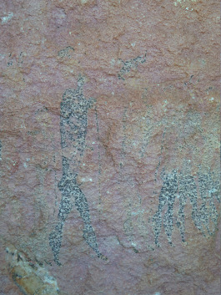  Original | 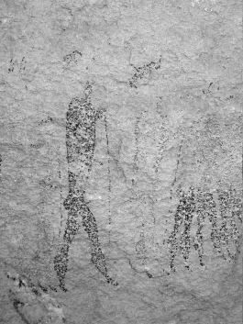  Red channel (R) | 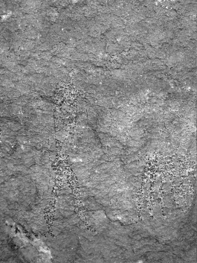  Green channel (G) | 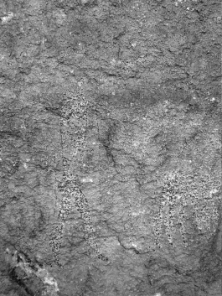  Blue channel (B)
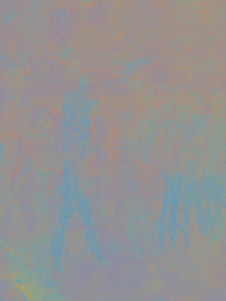  Orientation | 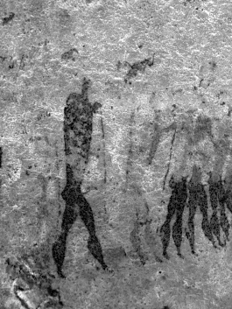  R | 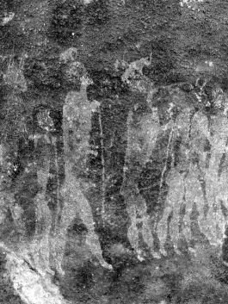  G | 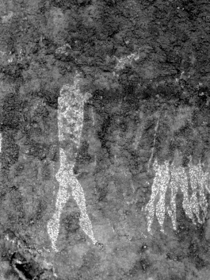  B
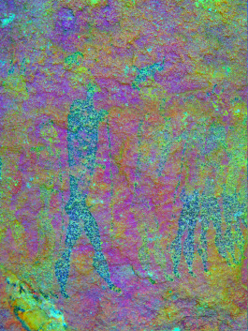  RDCS | 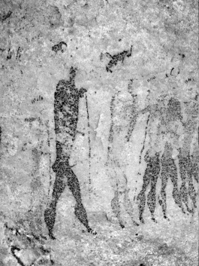  R | 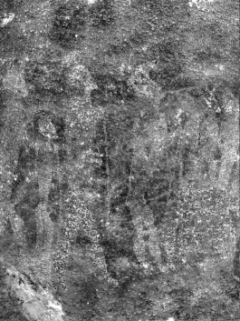  G | 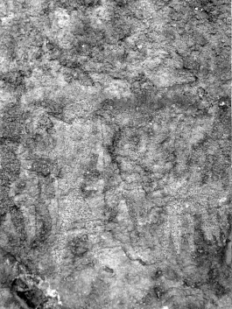  B
SOM Figure 1 (Parkington & Alfers Fig. 8). Comparison of different outputs as described in this supplementary section. This is a challenging image for enhancement. Each row, left to right, comprises a colour composite and the decomposed RGB channel grey-scale images. Whereas the RDCS image shows the most detail of the three colour composites, clearer details are evident in the RGB channels of the orientation output. Thus, the RGB channel images were used in the enhancement. The original image is corrected for colour cast.

Layer modes and opacity
In GIMP and most other editors, layered and stacked images have two principal adjustments – opacity and mode. Opacity defines how much effect the layer mode has on the layers below, from translucent (0% - none) to opaque (100% - full). Layer modes are more complex and represent set arithmetic interactions between pixel values of the upper and lower layers, resulting in a blended pixel output (see https://docs.gimp.org/2.10/en/gimp-concepts-layer-modes.html for an example). Modes such as overlay, softlight, subtract and darken only, in GIMP, are comparable to those found in popular commercial image editing software (e.g., Adobe Photoshop).

Choosing modes begins with the simplest combinations – all layers with 100% opacity in softlight mode in a stack over a grey-scale base image. Subsequent experimentation – changing modes, opacity, and layer order – resolves which combinations provide the best version of the detail of interest. These manipulations are done image-wide without spatial sub-setting.

4. Enhancement descriptions
Descriptions of enhancements provided below present – from left to right – the sequence of overlain layers as stacked from top to bottom in GIMP. Each source is identified as either orientation (Orient) or RDCS and the channel in the form Orient_ch0 (i.e., Red) or RDCS_ch1 (i.e., Green) etc. If the layer image is inverted it is shown as, for example, Orient_ch1inv. This layer identifier is followed by the layer mode (the type of blend) and a number representing the opacity such as RDCS_ch3_softlight75 (RDCS Blue channel in softlight mode at 75% opacity).

Finally, layers denoted greyscale (such as greyscale_darkenonly30) are greyscale versions of the original image and are useful in toning down highlights in order to make the images appear more natural. The base image is always fully opaque in the default (normal) mode.

5. Figure descriptions
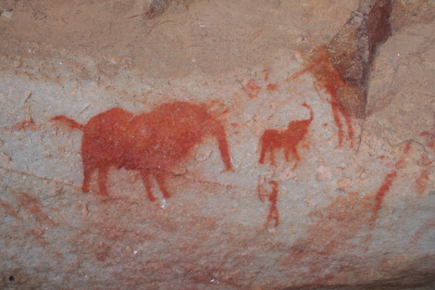 | 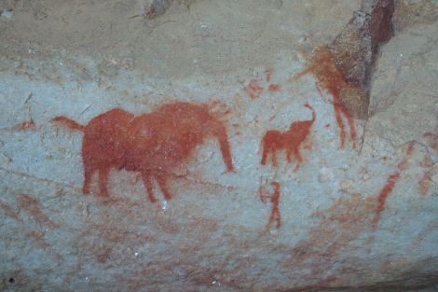 | 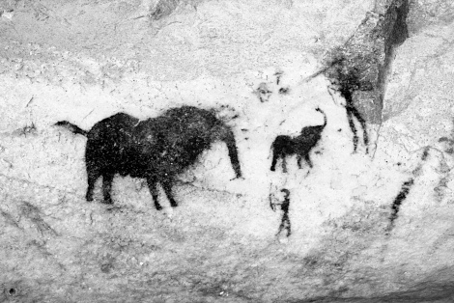
SOM Figure 2 (Parkington & Alfers Fig. 4). Left: digital camera image before colour cast correction. Centre: improved colour cast corrected image. Right: Orient_ch2_softlight100, Orient_ch1_overlay75, Orient_ch0_softlight100, Greyscale. Image source: Siyakha Mguni, UCT, available in SAHRIS.
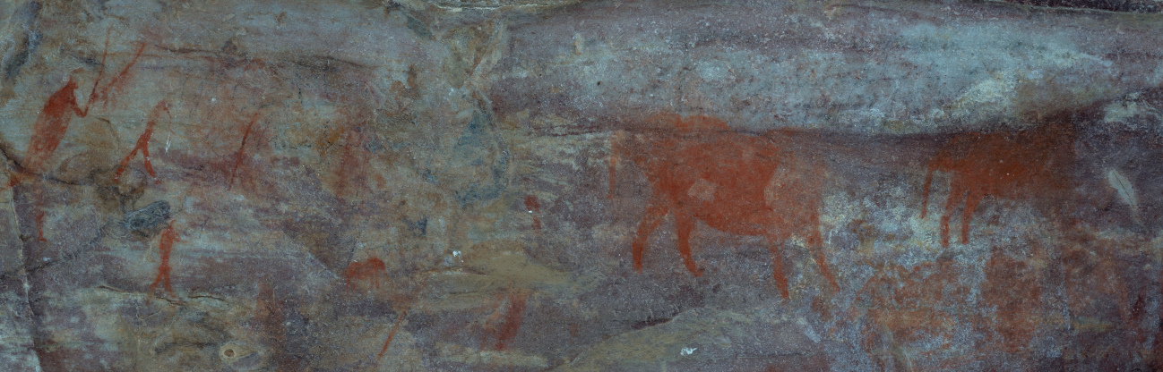
SOM Figure 3 (Parkington & Alfers Fig. 5). Colour cast corrected digital camera image.

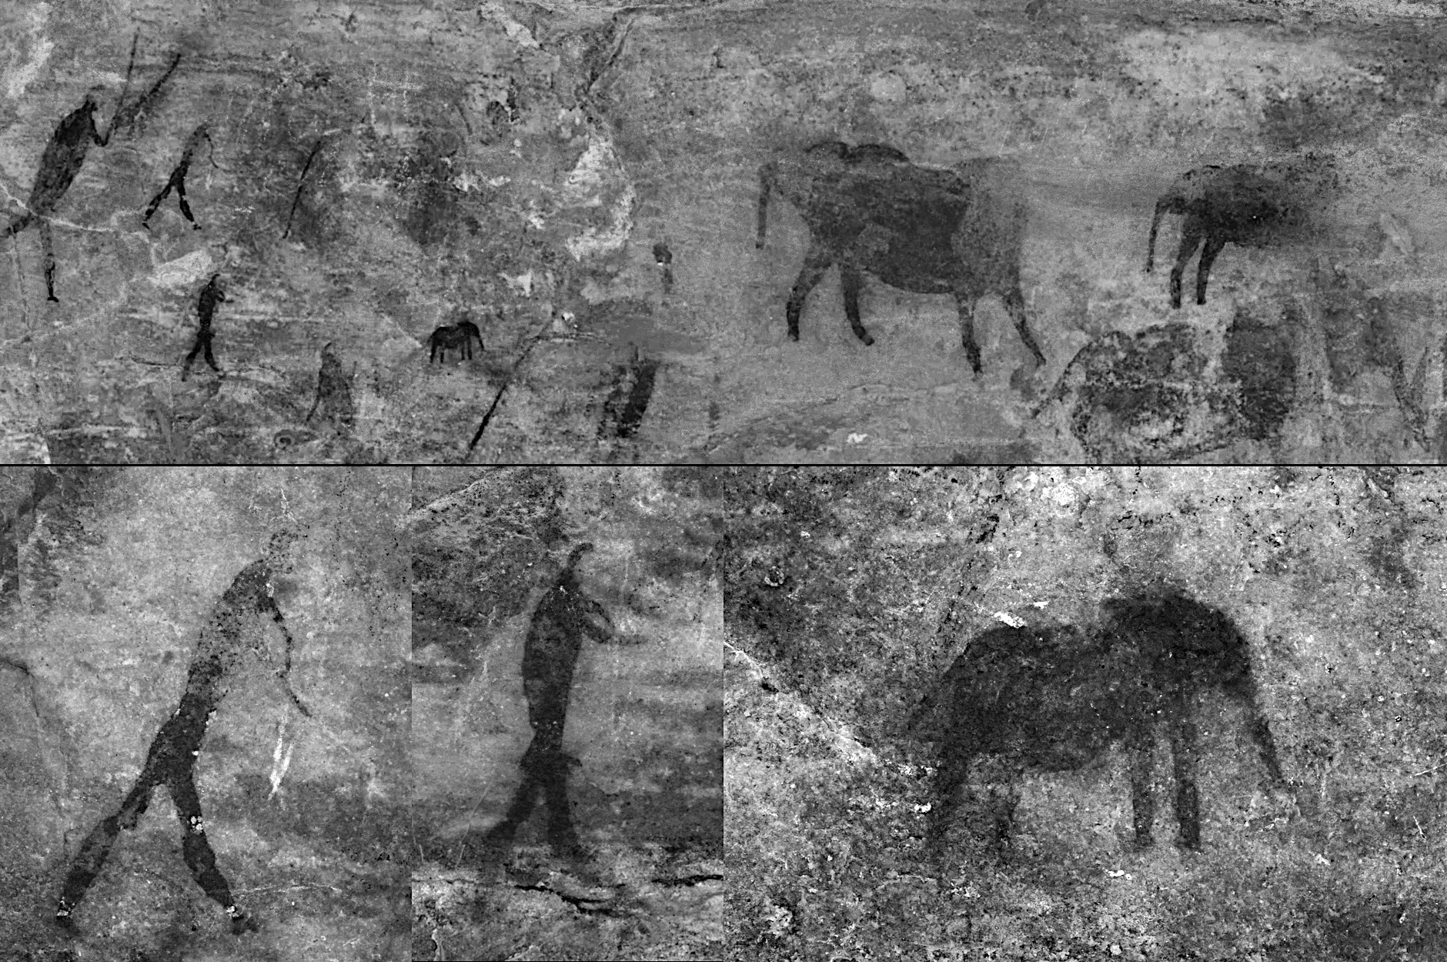
SOM Figure 4 (Parkington & Alfers Fig. 5). Top row: RDCS_ch2_softlight20; RDCS_ch1_softlight40; RDCS_ch0inv_normal50; Greyscale. Bottom row (left & centre): Bowmen, RDCS_ch2_softlight20; RDCS_ch1_softlight40; RCS_ch0inv_softlight40; Greyscale. Bottom row (right): Elephant, Greyscale_multiply30; RDCS_ch2_overlay35; RDCS_ch1_overlay40; RCS_ch0inv_softlight40; Greyscale. Image source: Stephen Wessels

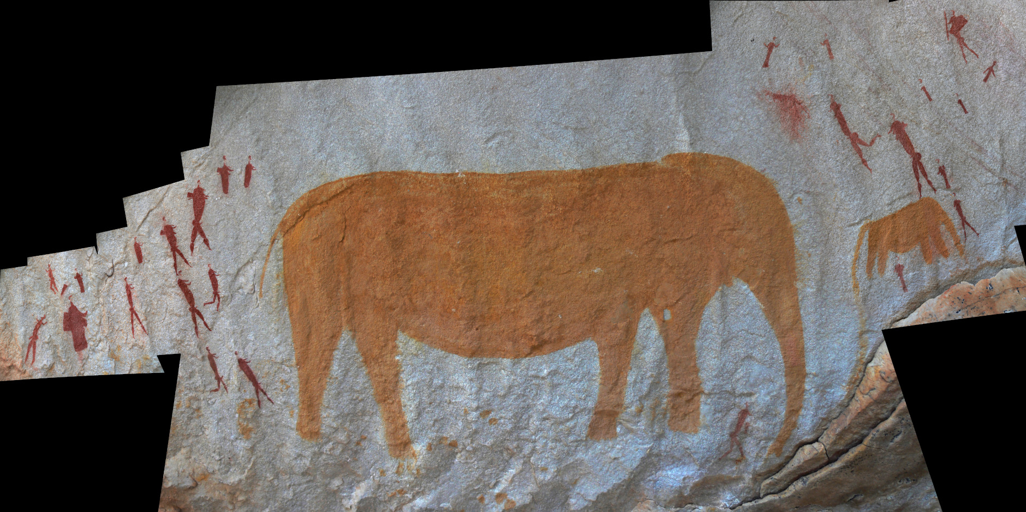
SOM Figure 5 (Parkington & Alfers Fig. 6). No single image provided the required coverage, so multiple colour cast corrected images were coalesced into three separate mosaics, using Hugin (The Hugin Development Team 2022), and were then subsequently enhanced. This shows the panel shot mosaic of digital camera images.
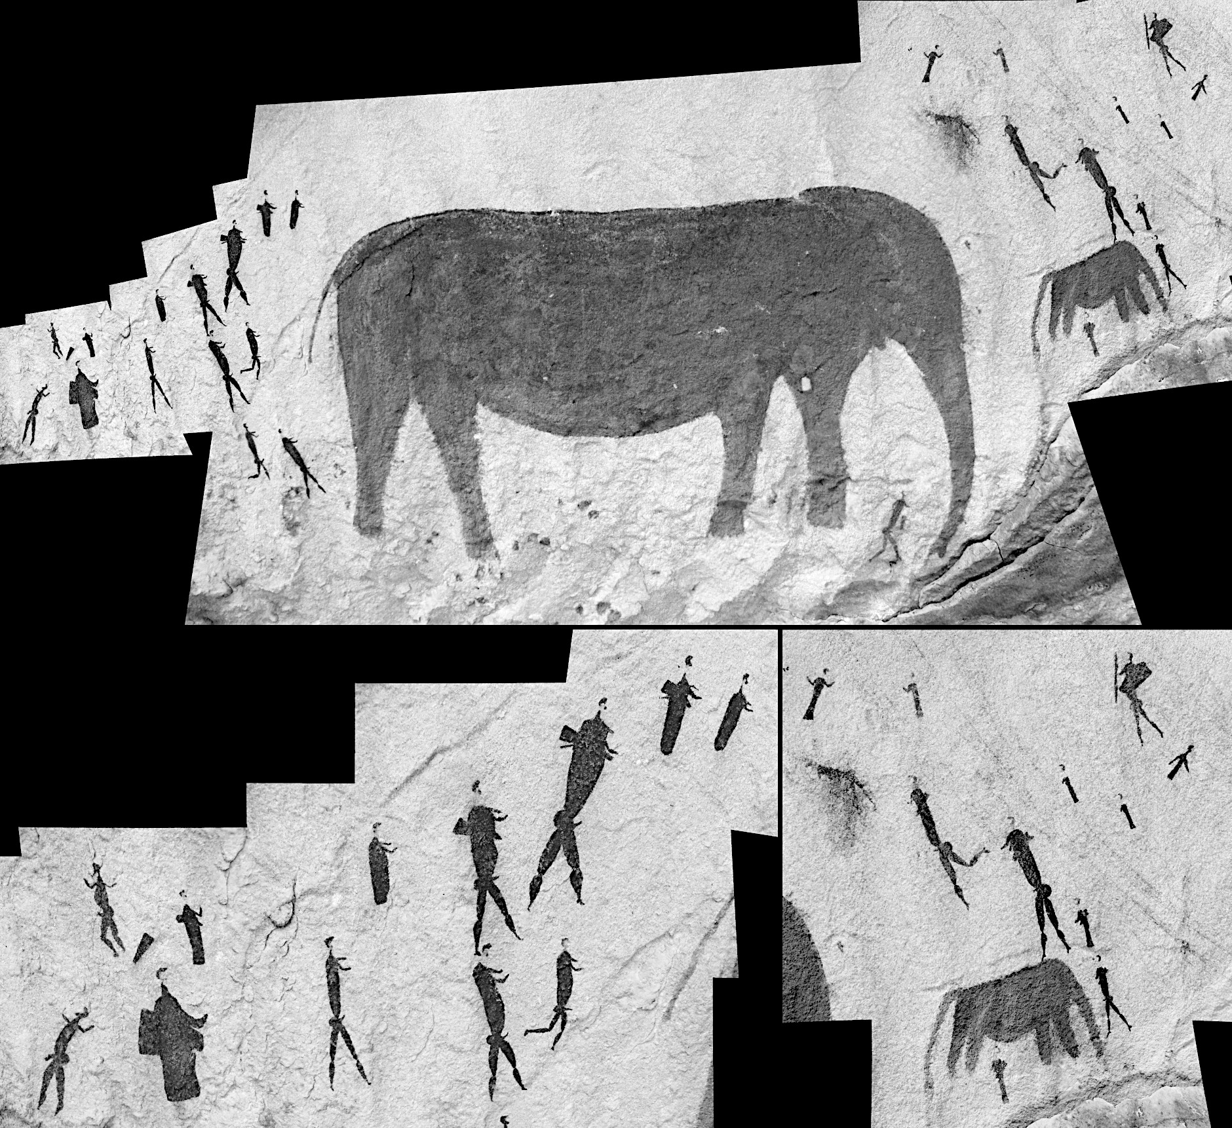
SOM Figure 6 (Parkington & Alfers Fig. 6). All: Orient_ch2_softlight100; Orient_ch1_softlight100; Orient_ch0inv_softlight100; Greyscale. Image Source: Arno Pitio, eCrag, available in SAHRIS.

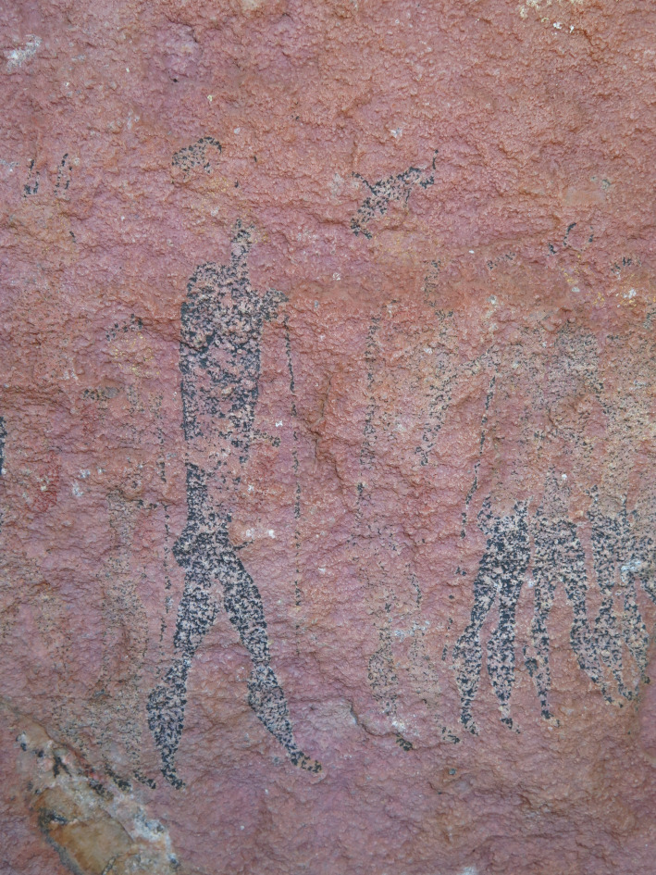
SOM Figure 7 (Parkington & Alfers Fig. 8). Digital camera image before colour cast correction (see also SOM Fig. 1).

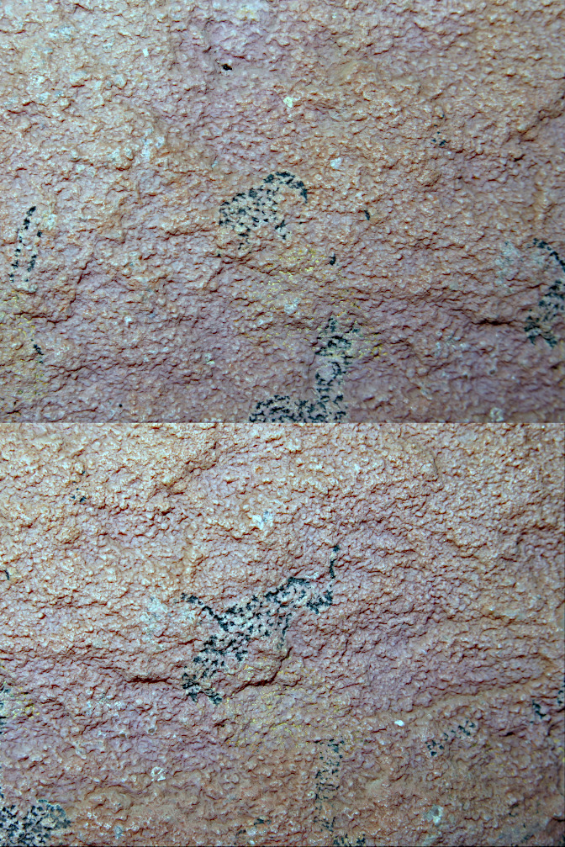 | 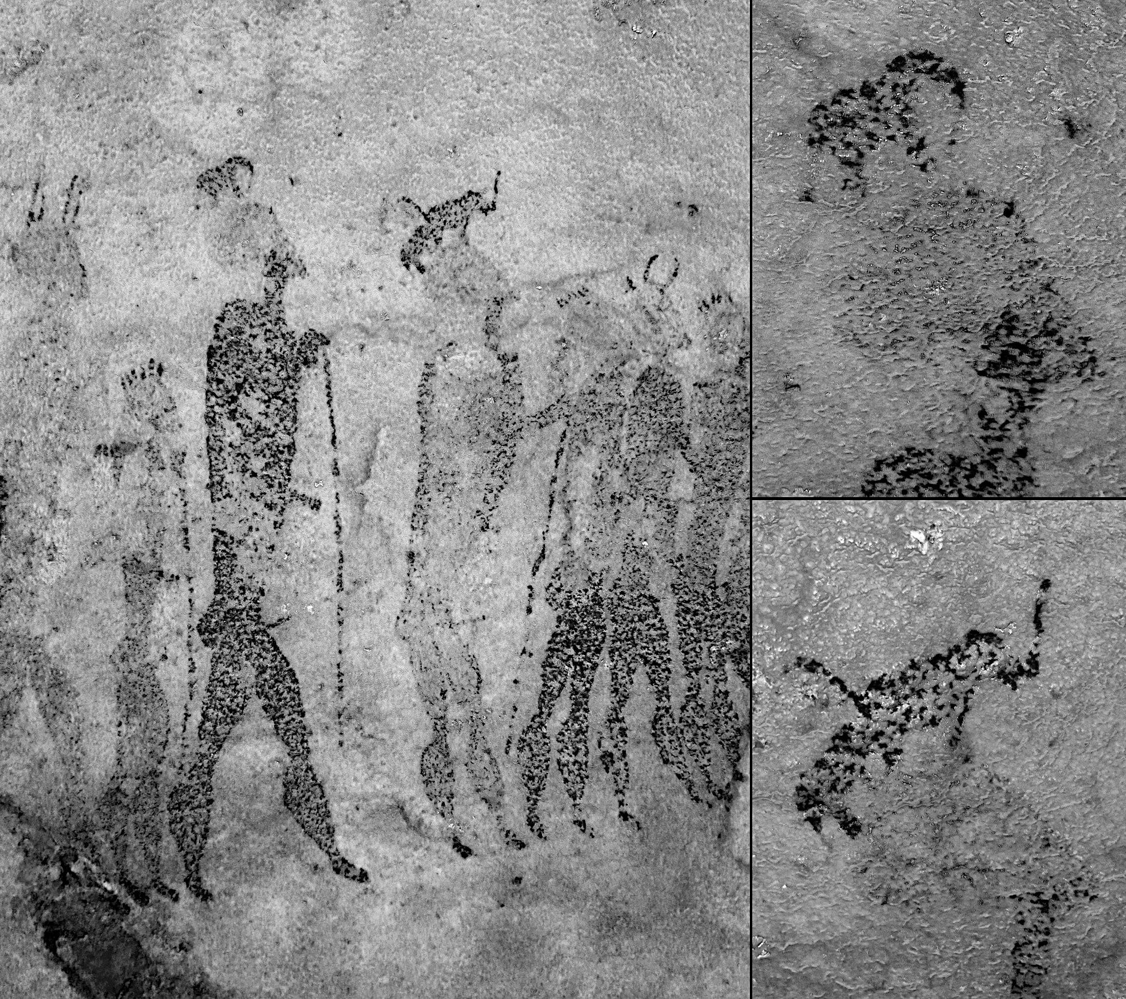
SOM Figure 8 (Parkington & Alfers Fig. 8). Left (top & bottom): colour cast corrected digital camera images of elephant on heads. Centre: line of figures, Orient_ch2_softlight30; Orient_ch1inv_softlight100; Orient_ch0_softlight75; Greyscale. Right (top & bottom): upper & lower details, Orient_ch2_softlight20; Orient_ch1inv_softlight100; Orient_ch0_softlight65; Greyscale. Image sources: Joe Alfers and Royden Yates.

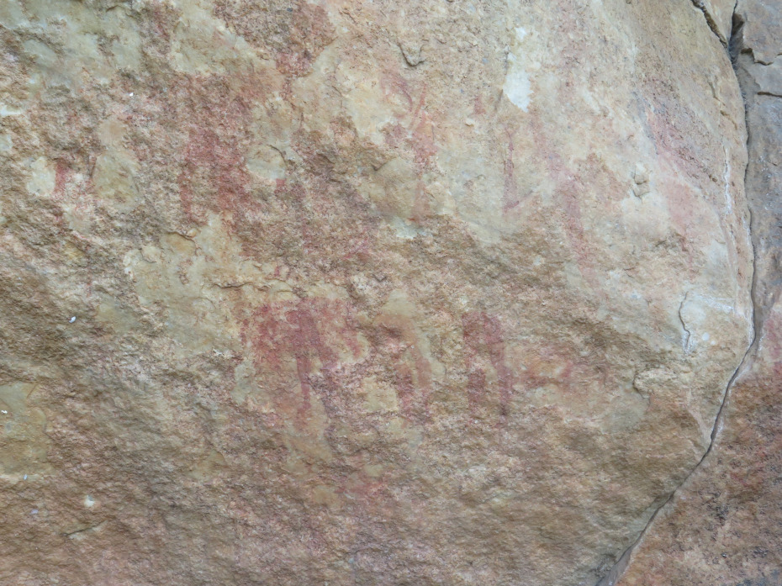 | 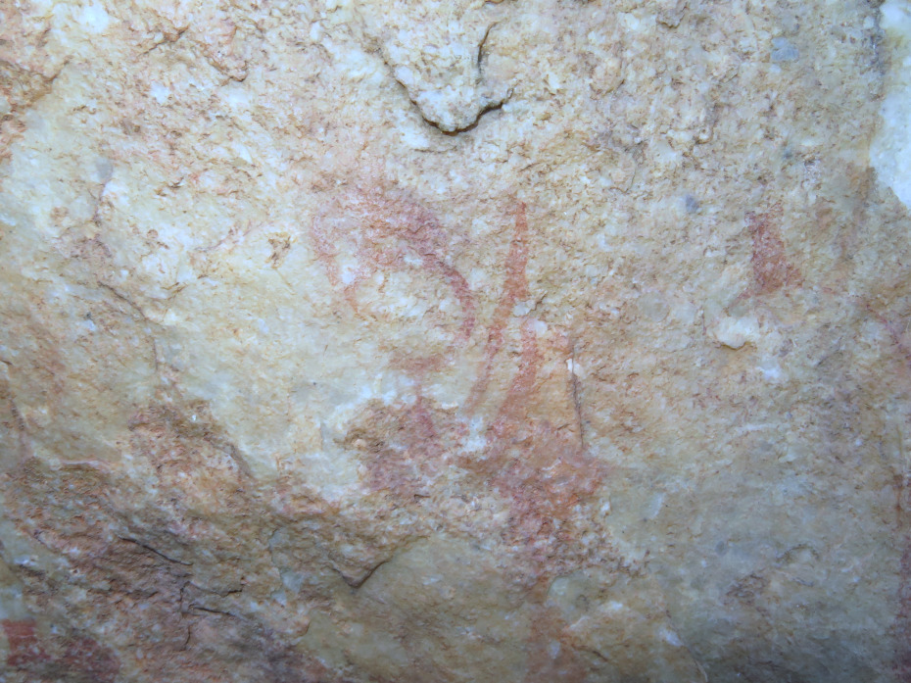
SOM Figure 9 (Parkington & Alfers Fig. 9). Left: digital camera image of line of red figures before colour cast correction. Right: colour cast corrected digital camera image of elephant on head.

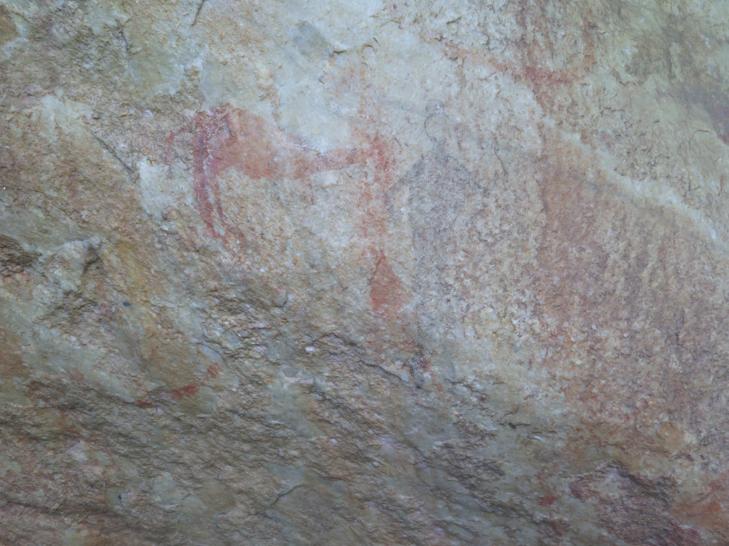  c | 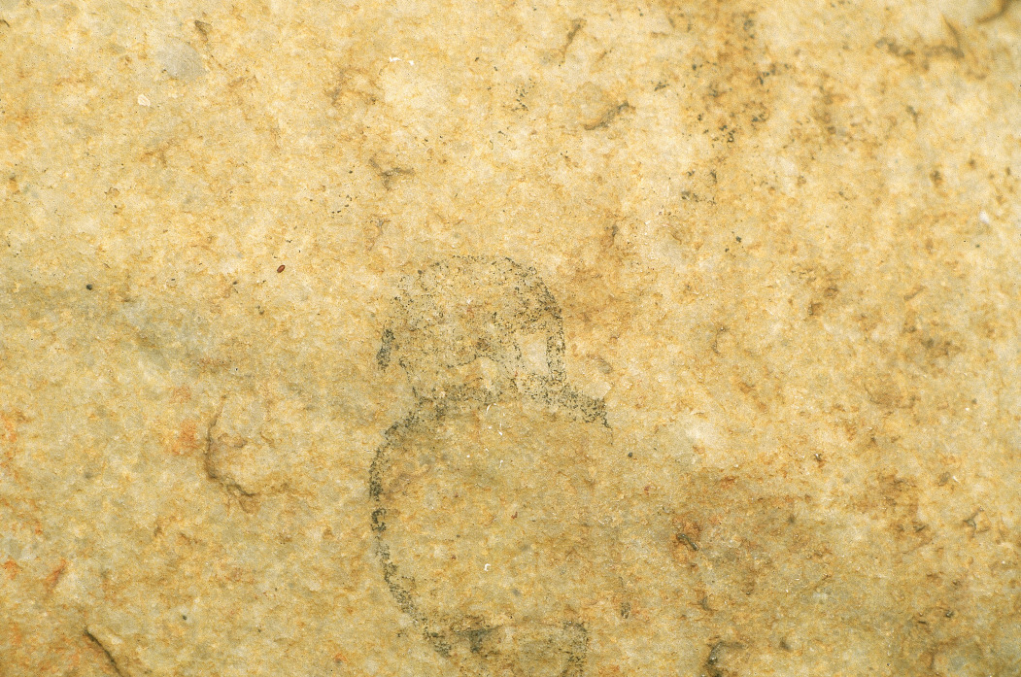
SOM Figure 10 (Parkington & Alfers Fig. 9). Left: colour cast corrected digital camera image of two black human figures, one just visible on the red antelope. Right: scan of colour slide of elephant on head.

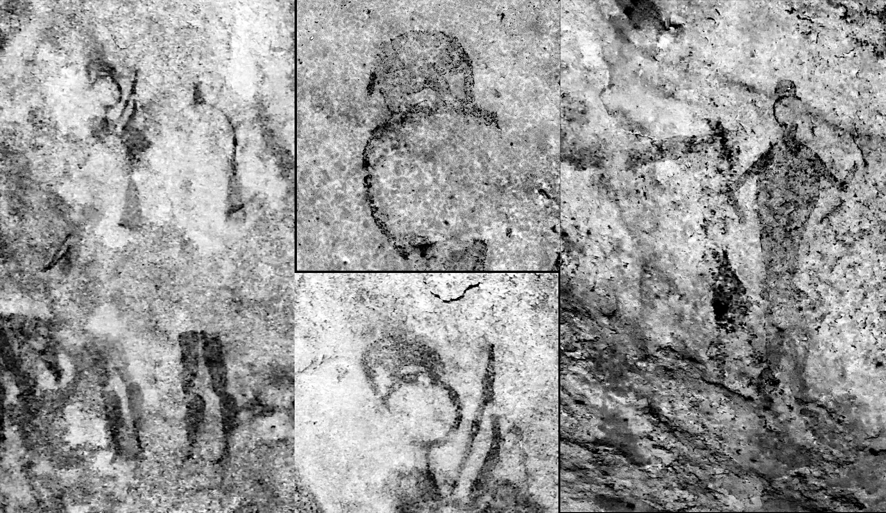
SOM Figure 11 (Parkington & Alfers Fig. 9). Left and centre (bottom): panel shot and detail, RDCS_ch2inv_softlight100; RDCS_ch0inv_softlight100; RCS_ch1_softlight100; Greyscale. Right: panel shot, Greyscale_softlight100; RDCS_ch2inv_softlight50; RDCS_ch0_darkenonly100; Orient_ch0inv_softlight50; RDCS_ch1. Centre (top): upper detail of elephant on head, RDCS_ch1_softlight50; RDCS_ch0. Image sources: all Royden Yates, except upper detail, UCT, available in ARADA.

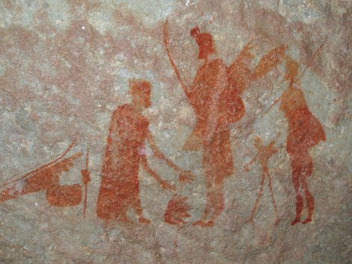
SOM Figure 12 (Parkington & Alfers Fig. 10). Digital camera image before colour cast correction.
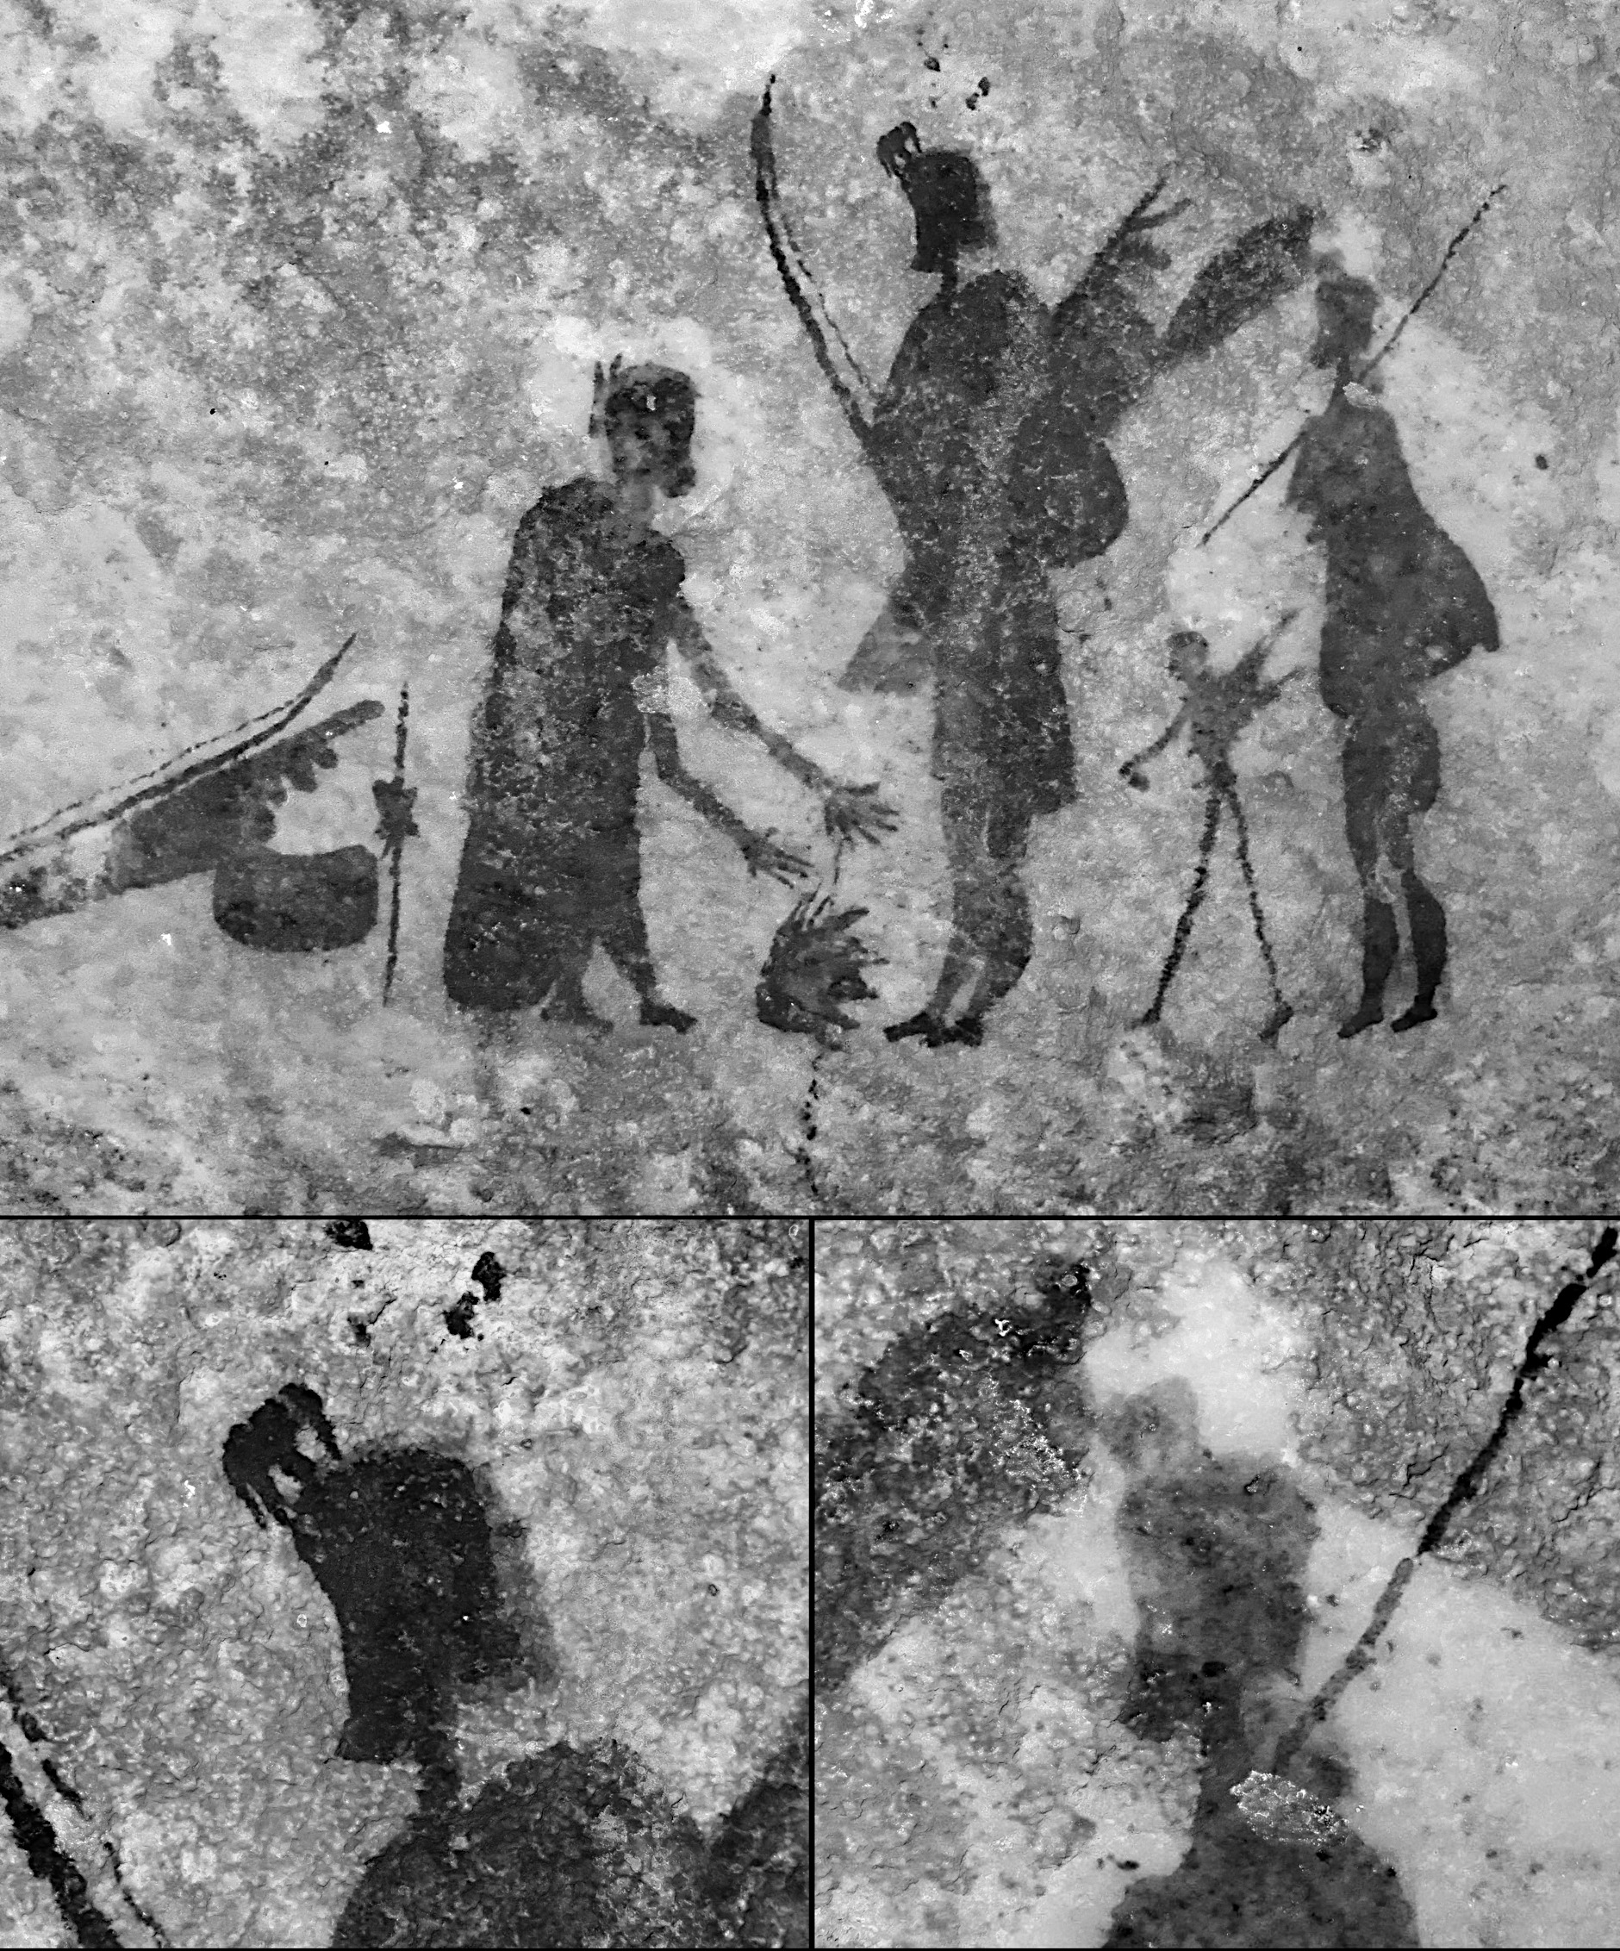
SOM Figure 13 (Parkington & Alfers Fig. 10). Top and bottom left: RDCS_ch0inv_softlight10; 0 RDCS_ch2_softlight100; RDCS_ch1_softlight50; Greyscale. Bottom right: RDCS_ch0inv_overlay100; RDCS_ch2_softlight100; RDCS_ch1_softlight50; Greyscale. Image source: Royden Yates

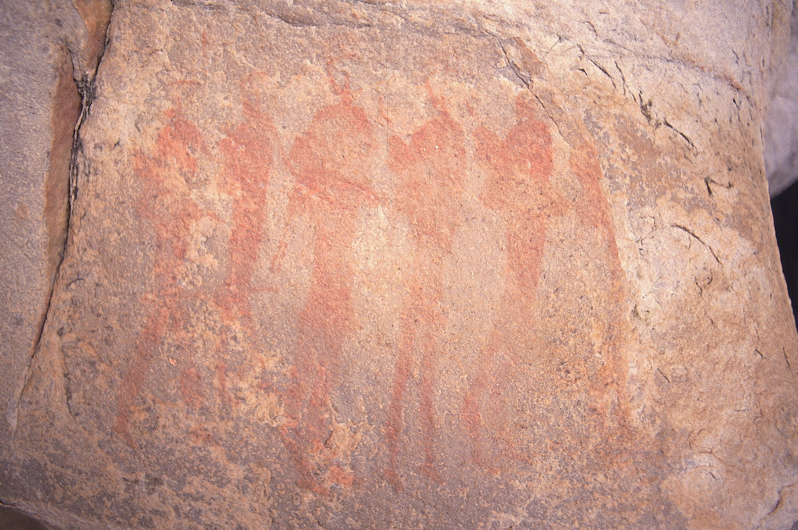 | 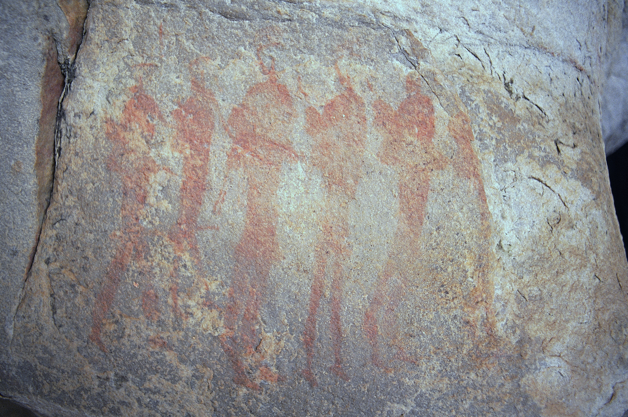 | 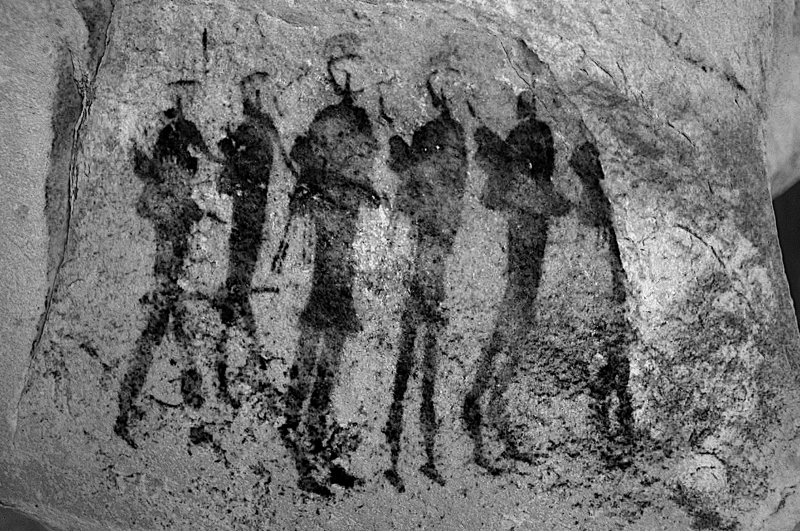
SOM Figure 14 (Parkington & Alfers Fig. 11). Left: scan of colour slide before colour cast correction. Centre: colour cast corrected image. Right: Greyscale_darkenonly100; RDCS_ch1_softlight100; RDCS_ch2_softlight100; RDCS_ch0inv. Image source: Janette Deacon, available in ARADA.

Acknowledgements
Azizo da Fonseca of ARADA helps always, as does Nic Wiltshire of eCrag. In distant lands Kristian Rosvall and Jan Ivar & Mariette Blixt provide much support.

References
ARADA 2022. The African Rock Art Digital Archive. Rock Art Research Institute, University of the Witwatersrand. Available from http://www.sarada.co.za (Accessed 2022).

Arizona State University 2022. Davinci. Available from http://davinci.asu.edu/index.php (Accessed 2022).

eCrag 2007-. Eastern Cederberg Rock Art Group. Available from https://sahris.sahra.org.za (Accessed 2022).

GIMP Development Team 2022. GIMP. Available from: https://www.gimp.org (Accessed 2022).

Harman, J. 2022. Dstretch: Rock Art Digital Enhancement. Dstretch. Available from https://www.dstretch.com (Accessed 2022).

Hugin Development Team 2022. Hugin. Available from: https://hugin.sourceforge.io (Accessed 2022).

ImageMagick Development Team, 2022. ImageMagick. Available from: https://imagemagick.org (Accessed 2022).

PIXLS.US 2019. Gimp: Invert and merge (to remove color cast). Available from https://discuss.pixls.us/t/gimp-invert-and-merge-to-remove-color-cast/12238 (Accessed 2022).

SAHRIS 2022. The South African Heritage Resources Information System. South African Heritage Resources Agency (SAHRA). Available from https://sahris.sahra.org.za (Accessed 2022).

Tschumperlé, D. & Fourey, S. 2022. G'MIC (GREYC's Magic for Image Computing): A Full-Featured Open-Source Framework for Image Processing. Available from https://gmic.eu (Accessed 2022).

